PLAN GRADER™
The future of healthcare is LOCAL, open and independent

Plan Grader™ analyzes the most important factors and practices of high-performance health plans, creating an independent assessment of the eight Health Rosetta components within the LOCAL adoption model.
Tackling these eight Health Rosetta components puts plans in the driver’s seat to improve health outcomes while controlling and reducing costs for you and your employees.
Plan Grader Sponsor
September 14, 2022
Prepared By: Health Rosetta

Your Overall Score: 51
*Median score is the average of all plans that have completed a Plan Grader™.

Your Score by Health Rosetta Component
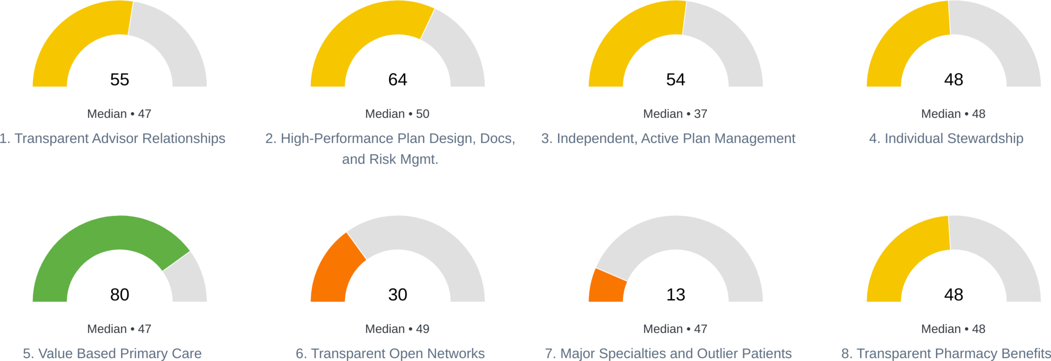

EXECUTIVE SUMMARY
The Health Rosetta framework is modeled on the successes of hundreds of high-performance plans. Your Plan Grader™ will help you repeat what they’ve done. To simplify the path, we’ve developed the LOCAL adoption framework.

L - Learn how to be liberated from the status quo
O - Optimize health plan infrastructure (e.g., risk mgmt., plan design, plan admin, plan docs/contract, data analysess, compliance)
C - Carve out Pharmacy Benefit Manager (PBM)
A - Add Value Based Primary Care (e.g., DPC and near site clinics)
L - Leave behind value-extracting PPO networks (e.g., direct contracting, bundles, cash pay, RBP)
Using the LOCAL process to adopt the Health Rosetta framework can help you provide better benefits for 20-40% less spend than status quo health plans. Four of the LOCAL steps are either positive to members or completely invisible to members, reducing fears of requiring major change. It also helps you offer benefits that attract and retain your workforce by freeing up resources to support your bottom line, people, and community.

The following pages contain a more in-depth view on each component within the overall context of the LOCAL adoption framework. After this, the rest of the report will walk your through custom recommendations based on your Plan Grader responses to help you decide where to focus your efforts.

Learn how to be liberated from the status quo
Transparent Advisor Relationships
Identify an advisor with aligned and transparent incentives that develops a 3-5 year strategy with you that is tailored to your specific objectives and constraints.
- Knows, manages, and discloses all advisor and vendor compensation sources and conflicts of interest
- Provides cost containment and risk mitigation strategies
- Doesn’t just shop carrier-controlled plans with “shock” renewal rates that perpetuate rapidly rising costs

Optimize health plan infrastructure
(e.g., risk mgmt., plan design, plan admin, plan docs & contracts, data analyses, compliance)

High-Performance Plan Design, Docs, and Risk Mgmt.
The contracts and plan documents are reviewed by a qualified third-party to ensure your plan is fully compliant and optimized to provide the best benefits at the lowest cost.
- Fully-compliant ERISA plans that protect your plan from abuse
- Aligned plan and vendor documents that create 360 degree risk mitigation
- Stop-loss and underwriting best practices to ensure plan assets are protected
- Smart plan design that incentivizes members to make smart healthcare decisions and reduces their costs, the key to a better member experience
Independent, Active Plan Management
All plan vendors have aligned incentives to lower health plan costs and improve quality, and you have the tools to oversee the plan and your vendors.
- Plan vendors with aligned incentives
- Third-party administration proactively manages claims and payments, leverages risk mitigation strategies, and pulls together the pieces of your plan
- Data access and analyses that empower you to oversee, audit, intervene, and improve your plan
Individual Stewardship
Members have resources to help navigate healthcare’s complexity and cost, supporting care journeys and benefit needs.
- Plan members have access to people and tools that help navigate benefits and care
- Quality and cost resources to help seek care at high value providers
- Information is clear and accessible, and plan members know where to go when they need help

Carve out Pharmacy Benefit Manager (PBM)
Transparent Pharmacy Benefits
Transparency and control over PBM services and drug costs.
- All pharmacy costs and expenses are known and contractually agreed to with the ability to audit
- Ensure clinical decisions are based solely on efficacy and actual drug costs
- Aligned incentives that work on behalf of the member and plan’s best interests
Add Value Based Primary Care (e.g., DPC and near site clinics)
Value Based Primary Care
Primary care with aligned incentive to achieve the Quadruple Aim (improve the care team experience, which naturally leads to an improved patient experience, in turn, leading to improved health outcomes and lower plan costs).
- 24/7 access to primary care team
- Member access to same or next day appointments
- A clinical team that proactively manages the health of the member population

Leave behind value-extracting PPO networks
(e.g., direct contracting, bundles, cash pay, RBP)

Transparent Open Networks
Access to care providers at fair, transparent prices to employer and members with high- quality care and reporting.
- Providers can set transparent prices agreed to by the plan
- Plan design that incentivizes members to go to preferred providers at no cost to them
- No surprise bills for employers or members
Major Specialties and Outlier Patients
Access to evidence-based and disease-specific care navigation, pathways, and treatment protocols.
- Second opinions and centers of excellence at no charge for employees
- Lower complication rates & avoidance of unnecessary procedures
- Highly coordinated care with defined handoffs between care providers

Transparent Advisor Relationships

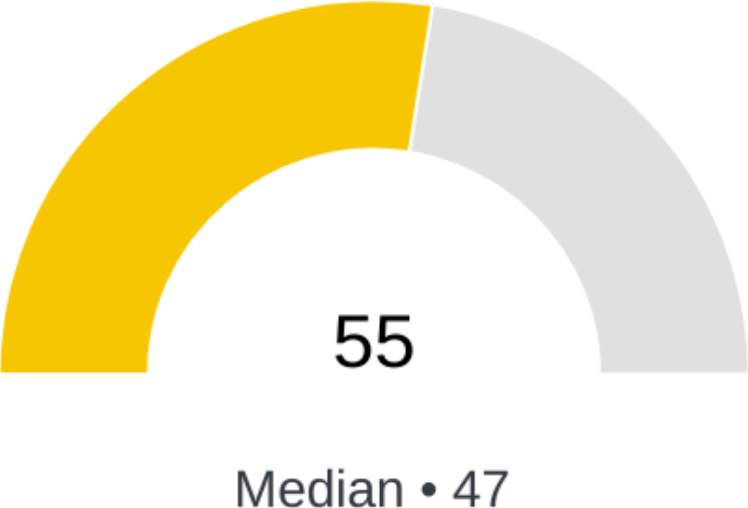
Did the plan's benefits advisor, completely disclose all direct and indirect compensation in a timely manner?
Trust is built on transparency and openness. The benefits industry is rife with conflicts of interest and hidden compensation that undermines this trust. The latest regulations requiring consultants and brokers to disclose direct and indirect compensation will help make it easy for you to surface these conflicts. Frequently, we view that the best advisors are undercompensated, while everyone else is over-compensated in ways they're not telling you about.
YOUR RESPONSE: Yes
POINTS SCORE: 1/1 possible points
KEY ISSUES
By requesting disclosure of all compensation sources, you've already created the foundation for a trusted relationship with your advisor and are further ahead than most plans. The latest regulations are increasing the breadth and depth of disclosures. Be sure you receive these before making critical decisions. Additionally, request disclosure on compensation for voluntary and non-health benefits as well to get a full picture.

Which of the following is most accurate about the plan's stop loss fees/commissions?
Stop loss fees and commissions are a common source of undisclosed compensation. Latest regulations will simplify uncovering these types of conflicts.
YOUR RESPONSE: Part of advisor's consulting fee is stop loss fees/commissions, but was not disclosed
POINTS SCORE: 0/3 possible points
KEY ISSUES
Stop loss fees and compensation are a common component of advisor and/or Plan Administrator compensation. While this isn't bad, there is frequently a source of undisclosed compensation that is sometimes excessive. Be sure to request complete disclosure of all compensation to any party related to your stop loss coverage. If you're fully-insured, be sure to request disclosure of all commissions.

Which of the plan's solution partners contractually agree to disclose all direct and indirect sources of compensation?
Similar to benefits advisors, many vendors have multiple sources of compensation, frequently undisclosed. We've identified more than 15 sources just for PBM's, yet clinicians only receive $0.27 of every $1 spent on healthcare. Contractually requiring disclosure is a simple way to hold your vendors accountable.
YOUR RESPONSE: Concierge Service; Medical Add-in Solutions
POINTS SCORE: 3/10 possible points
KEY ISSUES
Congratulations, at least some of your solutions partners are committing to disclose actual and potential conflicts of interest. We recommend reviewing these disclosures at your next renewal to ensure that compensation levels are appropriate and that you're receiving disclosures required by latest regulations, even if solution partners aren't contractually committing to provide them. Doing so is required to meet regulatory requirements for plan sponsors.

High-Performance Plan Design, Docs, and Risk Mgmt.

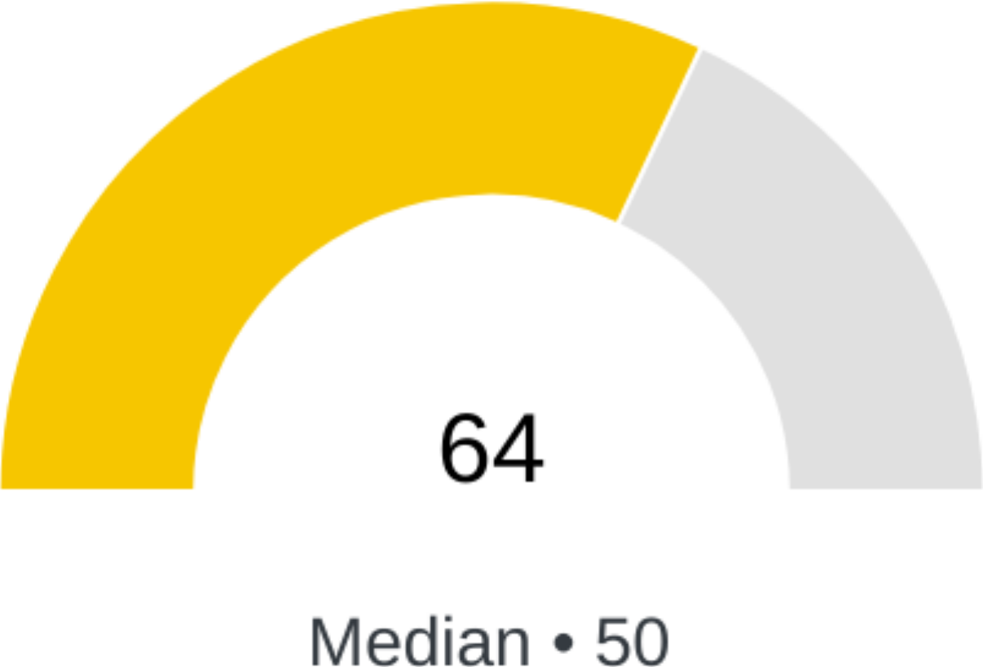
What is the plan's current funding mechanism?
The truth is that all employers are self-funded. Why do we say that? If you have higher than expected claims in one year, a fully-insured carrier will recapture those losses and more in subsequent years. Even worse, a bad year with a fully-insured carrier resets your baseline, ensuring that every subsequent year will have higher premiums. Intelligent self-funding strategies can both effectively manage risk and ensure that one bad year doesn't affect you for the next decade.
YOUR RESPONSE: Self-funded w/ stop-loss
POINTS SCORE: 3/3 possible points
KEY ISSUES
Congratulations, you're already tackling some version of self-funding. You now have additional flexibility to optimize your plan and capture cost savings. However, your next renewal should focus on ensuring your current program and vendors are providing you with the flexibility necessary. This may include changing underwriters or stop loss carriers, or ensuring that your contract is giving you the right level of risk mitigation. You may also need to change your plan administrator to effectively tackle this issue since many carrier-administered self-funded programs operate largely unchanged from status quo fully-insured health plans.

What member cost share waivers does the plan leverage?
We've observed that high-performing plans make good decisions free or near free, and poor decisions costly. As the author Michael Lewis said about the 2008 financial collapse, "The complexity disguises what's happening. If it's so complicated that you can't understand it -- then you can't question it." Be careful of overly complex co-pay, deductible, etc. structures.
YOUR RESPONSE: Deductibles; Premium holidays
POINTS SCORE: 3/6 possible points
KEY ISSUES
Premium credits and holidays, as well as other incentives, can be effective, but we've found the most successful incentives apply to specific episodes of care where the opportunity to improve the quality of care while lowering costs is greatest.
Removing barriers to great health outcomes, such as costly deductibles, coinsurance, and certain copays, is a critical element of high-performance plans. You're already doing at least some of this. We recommend reviewing your strategy with your advisor during your next renewal to ensure the incentives you're providing support helping members receive high-value care and your organization's objectives.

How does the plan incentivize members to seek lower cost and/or higher quality care?
Traditional plan design changes are frequently insufficient incentives. High-performing plans create more compelling incentives and innovative plan design features to simplify making care decisions that lower costs and/or improve quality. Fortunately, higher quality care is usually lower cost care too, the opposite of what we experience in the rest of life.
YOUR RESPONSE: Reduced/no cost share for specific medications; Reduced/no cost share when independent primary care refers care
POINTS SCORE: 4/12 possible points
KEY ISSUES
Congratulations, you're already employing more advanced incentives that are typically more effective. You might want to review during your next renewal, but your strategy may be working as intended and any improvements will come from member education.

How does the plan penalize members for not seeking lower cost and/or higher quality care?
Some plans incentivize members through penalties or other negative consequences for poor choices. Whether and how you do this requires careful consideration with your advisor.
YOUR RESPONSE: No coverage for not seeking referral from primary care provider; Other
POINTS SCORE: 2/5 possible points
KEY ISSUES
While we all prefer carrots over sticks, the medical and financial stakes are high. Preventable medical mistakes are the third leading cause of death and medical bills the biggest driver of bankruptcy (with 70% of those having "insurance"). By having no penalties, the biggest "penalties" will ultimately hit the member, such as preventable medical mistakes or financial distress.

How did the plan determine its specific stop-loss deductible amount?
Independently understanding your plan's risk profile and expected claims is a key piece of an effective self-funding strategy. Selecting the right specific deductible is the most foundational piece of your risk management strategy, particularly if you're a smaller group under 1,000 employees.
YOUR RESPONSE:
POINTS SCORE: 0/4 possible points

How is the Plan Sponsor claims budget created?
Independently understanding your plan's risk profile and expected claims is a key piece of an effective self-funding strategy. Relying on expected aggregate claims from your stop loss carrier is only one piece of an effective strategy.
YOUR RESPONSE: The sponsor's advisor created aggregate liability budget amounts; Used premiums provided by the plan administrator
POINTS SCORE: 4/5 possible points
KEY ISSUES
Actuarial analyses are the best ways to develop claims budgets, but using numbers created by your stop loss carrier, full-insured carrier, or advisor can also be effective, though often not as precise or reliable. Work with your advisor to select the most appropriate method that meets your objectives.

Who reviews the plan's SPD/Plan Documents?
An optimized SPD (Summary Plan Description) may sound mundane, but it's the master key that unlocks the door to high-performance health plans. Too often, they're document templates created by organizations with seriously misaligned incentives. Plus, the DOL is becoming more aggressive in auditing plans. Better plan documents reviewed by subject matter experts and attorneys help protect the plan.
YOUR RESPONSE: Non-attorney consultant
POINTS SCORE: 3/8 possible points
KEY ISSUES
Congratulations, you've had at least some level of review of your SPD, which is more than most plans. Ideally, your own ERISA attorney and benefits expert would review this. This benefits expert could be your advisor or other third party. We recommend reviewing your SPD to ensure it meets all compliance requirements (including the latest ones) and that detailed coverages/exclusions match your objectives. Reviewing the schedule of benefits may also be an opportunity to incorporate high-performance plan design strategies, such as waiving member cost shares for making prudent health decisions.
ADDITIONAL RECOMMENDATIONS
Congratulations on ensuring that your plan document was reviewed by a subject matter expert. Legal reviews will only get you part of the way to an effective plan document.

Which diagnoses and/or procedures are plan members incentivized to seek a second opinion?
General access to second opinions is one piece of the puzzle, but the highest performing plans strategically ensure that their strategies are tailored to common types of high cost, error prone complex care. These areas are where they typically focus this work.
YOUR RESPONSE: Cancer; Non-specialty drugs
POINTS SCORE: 4/20 possible points
KEY ISSUES
There are a wide range of specialty areas that benefit from second opinions. Because of the breadth of this, we recommend working with your advisor to create, review, and/or improve your strategy to address these specialties. We've found that frequently the most effective place to start is cancer, orthopedics, maternity, transplants, specialty drugs, and mental health because they can have the most immediate improvements in both cost and quality, as well as being high cost and utilization specialties in nearly every plan.
Remember, building a strategy for each specialty doesn't mean having a separate vendor for each specialty. Frequently, advanced primary care can tackle at least some elements of an effective strategy for every specialty, so that may be a great place to start.
ADDITIONAL RECOMMENDATIONS
Orthopedic procedures are an important place to focus because they are a common source of over treatment. The United States performs double the number of orthopedic procedures as other developed nations without any improvement in quality of life as a result of those procedures.
Americans are prescribed antidepressant, anti-anxiety and anti-insomnia medications at 50-130% higher rates than similar countries such as the UK, Germany, and the Netherlands. Some classes of medications, such as benzos, possess high addiction risk and brutal withdrawals, making second opinions particularly helpful.

Who performs the review to ensure there are not gaps in coverage or conflicts across all of the plan's vendor contracts, policies, and SPD/plan documents?
While negotiating and reviewing each agreement and plan document in isolation is important, ensuring that they all work together to protect you and make certain you have no gaps in coverage is just as important. The most critical element of this is ensuring no gaps in coverage exist between stop loss policies and plan documents or employee handbooks.
YOUR RESPONSE: ERISA attorney at the advisor's firm; No third-party review
POINTS SCORE: 5/8 possible points
KEY ISSUES
Congratulations, you've had at least some level of review to ensure your agreements work together to protect your plan, organization, and members. The most common high-risk issue we see is conflicts between SPD's/plan documents, employee guides/policies, and stop loss policies. Gaps or conflicts between these documents can result in a lack of stop loss coverage in some cases. We recommend ensuring this issue does not exist at each renewal, particularly when you change stop loss carriers. If you are fully-insured, this issue is less likely to exist, but work with your advisor to confirm.
ADDITIONAL RECOMMENDATIONS
If you've only had a legal review of your agreement, be sure to have a domain expert such as an expert at your advisor's firm or other third party service review your agreement for complex business issues that attorneys aren't experts in.

Does the plan include incentives for seeking a second opinion for certain diagnoses or procedures?
Many complex and expensive procedures and diseases have misdiagnosis or mistreatment rates of 20-60%. This is one of the key drivers of preventable medical mistakes being the third leading cause of death. Every high-performing plan we've studied effectively ensures members receive second opinions for complex care and diseases.
YOUR RESPONSE: Yes, coverage requires getting second opinion
POINTS SCORE: 1/1 possible points
KEY ISSUES
Congratulations, you're already doing more than most. When the Mayo Clinic provides second opinions on cancer cases, they not only change the diagnosis 20% of the time, they change the care plan 40% of the time. Other complex conditions have similar statistics. We suggest requiring second opinions for at least some complex conditions.
The exact way you incentivize members to obtain second opinions should be developed in partnership with your advisor. We recommend you review your current approach with your advisor to ensure you have the right incentives and partners for your population. This should include ensuring you have the right analytics and reporting to help you understand how well your current strategy is working. Also, consider how you are communicating success stories in your member communications to demonstrate value to your members. Lives saved and much better financial outcomes is a powerful message to convey.

Who reviews the plan administrator's Administrative Services Agreement (ASA)?
Your Administrative Services Agreement (ASA) is a critically important agreement. It dictates how your plan administrator will support your plan, accountability, access to data, fiduciary liability, and dozens of other critical issues. Not reviewing and negotiating it is like buying a company each year without bothering to read the Merger/Acquisition Agreement.
YOUR RESPONSE: ERISA attorney at the advisor's firm; No independent review
POINTS SCORE: 5/8 possible points
KEY ISSUES
Congratulations, you've had at least some level of review of your ASA agreement, which is more than most plans. Ideally, your own ERISA attorney and a domain expert would review this, but frequently you can rely on an advisor or other solution that does the legal and expert reviews on your behalf. We recommend confirming that your agreement is optimized during your next renewal.
ADDITIONAL RECOMMENDATIONS
If you've only had a legal review of your agreement, be sure to have a domain expert, an expert at your advisor's firm, or other third-party service review your agreement for complex business issues that attorneys aren't experts in.

Independent, Active Plan Management

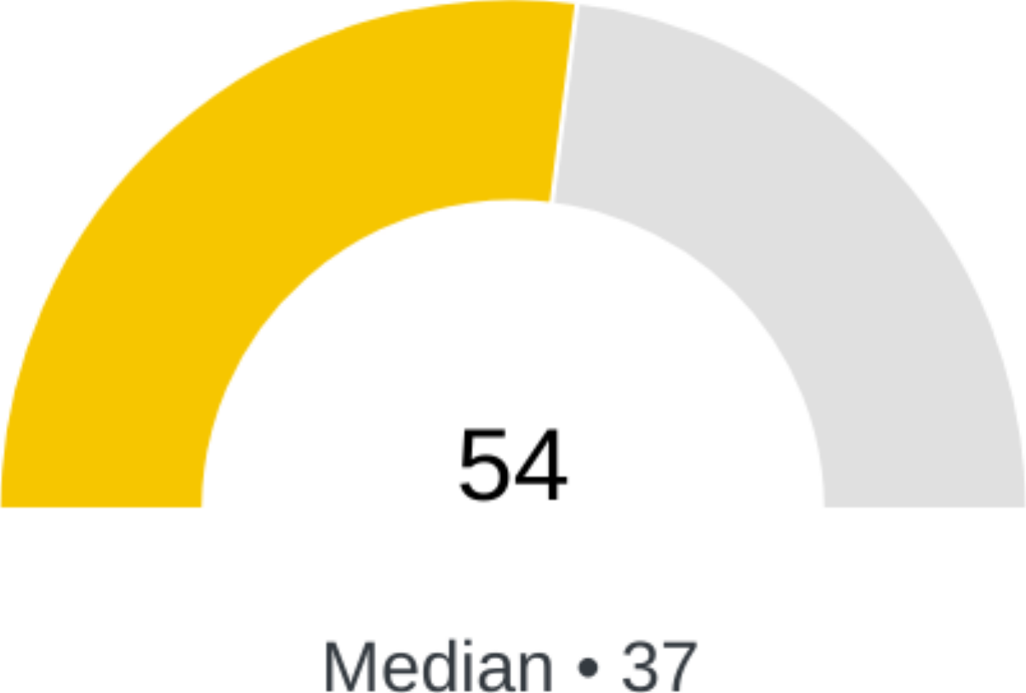
Who is deeply involved in your plan's annual review?
HR is central to the annual benefits review, planning, and design process. However, since a sound health plan can have the same EBITDA impact as a 25+% increase in revenue, HR shouldn't be the only department integrally involved in the process.
YOUR RESPONSE: CEO/President
POINTS SCORE: 1/9 possible points
KEY ISSUES
Even if you don't have an HR department, whoever is responsible for your benefits plan should have a seat at the table. Consider what core team members and decision-makers should be included if you don't have an HR or benefits leader.
ADDITIONAL RECOMMENDATIONS
Congratulations on including executive team members in the annual benefits process! Health plans are a major P&L line item and significant element of building a high-performance workforce. If you haven't formalized this into a structured decision-making process, it may be worth considering educating executive teams on potential strategies. We've even seen some organizations use approaches like SWAT and Kaizen to help ensure effective decision-making. You may also want to review whether you've included all the right executives.
We've observed that many high-performing plans will also include non-leadership representatives in health benefits plan decision-making. You may want to consider adding this to your next renewal process. One way or another, employees are very involved with your organization's health plan. Having employee representation in the benefits review and design process increases buy-in and helps avoid blind spots.
Often key leaders beyond HR and finance are influential. On your next renewal, consider whether to include any other leaders.

Does the Plan Sponsor have a 3-5 year plan strategy?
Organizations have long-term plans for all critical functions (e.g., sales, HR, finance, etc.), yet often only plan on 12-month cycles for health plans. The most successful organizations have 3-5 year health plan strategies to help ensure long term cost containment and improve employee retention. Many of the most successful organizations we've seen retain employees for 5-10 years.
YOUR RESPONSE: Yes
POINTS SCORE: 1/1 possible points
KEY ISSUES
Congratulations for having a 3-5 year health plan strategy. The next step is to regularly review and work with your advisors to ensure that strategy is comprehensive.

How does the Plan Sponsor currently communicate benefits to members?
Because people learn in different ways, there is no one silver bullet way to communicate health benefits to employees. We've observed that higher-performing plans communicate through multiple channels carefully selected to match their member's needs.
YOUR RESPONSE: Regular bulk emails; Virtual open enrollment meetings
POINTS SCORE: 2/17 possible points
KEY ISSUES
Deciding how to communicate with your members is highly dependent on your population and how they prefer to communicate. Since there isn't a one size fits all approach, here are some issues to consider when building the right strategy for your plan.
1) Create a single source of truth for your benefits information
2) Vary between physical and digital approaches to meet people where they are
3) Be consistent and stick to a schedule
4) Remember to consider how best to reach non-employee plan members
5) Ask your solution partners to tell you what's worked best for them with their other clients

Does the Plan Sponsor have a standing employee benefits committee, focus group, etc.?
Generally, we've found that high-performance plans engage with key stakeholders across multiple roles. Your exact stakeholders may vary from the options here, but should be tailored to your organization.
YOUR RESPONSE: Yes, management and non-management
POINTS SCORE: 5/5 possible points
KEY ISSUES
Congratulations, you're already engaging both management and non-management. Ways to further improve might include educating and brainstorming how to tackle new challenges that arise. Top-performing organizations focus on making their health plans a competitive advantage.

How frequently does the Plan Sponsor communicate with employees about benefits?
The right cadence to communicate with plan members about health benefits varies, but we've observed that higher-performing plans communicate more frequently with their members and put meaningful effort into educating their plan members.
YOUR RESPONSE: Bi-monthly
POINTS SCORE: 4/5 possible points
KEY ISSUES
Looks like you're already communicating regularly with members. Keep it up and be sure to revisit the content of your communications and measure whether you're reaching all members, including non-employees. As we're sure you're aware, member communications is complex and requires consistent evolution.

Does the plan's Third-Party Administrator (TPA) allow the Plan Sponsor to select its Pharmacy Benefits Manager (PBM)?
A common attribute of good plan administrators is that they'll let you select the right PBM, so long as you give them enough time to appropriately integrate with a PBM they haven't worked with before.
YOUR RESPONSE: Yes, but only to certain PBMs
POINTS SCORE: 1/2 possible points
KEY ISSUES
Whether you can't choose your own PBM, aren't sure, or you can only select certain approved ones, your flexibility to select the best options for your group is limited. You should dive into this issue with your advisor at your next renewal. If you're fully-insured, consider some form of self-funding at your next renewal.
ADDITIONAL RECOMMENDATIONS
Note that there are reasonable reasons a plan administrator might not want to integrate with new PBM's they haven't worked with before. Be sure to understand why they only want to work with certain PBMs. Specifically ask if they receive compensation from their partnered PBMs.

Does the Plan Sponsor currently have unrestricted access to full claims data (not just reports)?
Put simply, if you don't have unrestricted access to full claims data, you can't effectively manage your plan. An experienced benefits advisor can almost always help you get full access to claims data from existing vendors or help you select new ones. The more difficult your claims administrator makes it, the more you can guarantee bad things are happening in your plan. Note that if you're fully-insured, you'll need to change your funding structure to access this data.
YOUR RESPONSE: Yes, medical only
POINTS SCORE: 2/4 possible points

ADDITIONAL RECOMMENDATIONS
You're part of the way there. We recommend requesting access to pharmacy claims data as soon as possible and reviewing the data you receive to ensure that you have all fields necessary to perform any data analyses. A good advisor will be able to support you on this.

Does the plan's Third-Party Administrator (TPA) let the Plan Sponsor select the dollar amount threshold for auto-adjudicating claims?
A common mistake is assuming that high auto-adjudication rates are automatically a good thing. Often, the opposite is true. One indicator of a good TPA is the ability to work with them to determine what claims to auto-adjudicate and what claims are subject to additional automated or manual review.
YOUR RESPONSE: Yes
POINTS SCORE: 1/1 possible points
KEY ISSUES
Great, this is one initial foundation of effective payment integrity practices. During your next renewal, you might consider bringing this topic up as the start of a broader payment integrity conversation with your plan administrator. Potentially, even decide to lower this threshold until you gain confidence in the payment integrity of your claims payment process. Remember, auto-adjudication thresholds can be set for specific dollar amounts, certain types of claims, types of care, and other criteria.

Does the Plan Sponsor use claims audits and/or payment integrity services to reduce fraudulent claims payment and identity theft risk?
Effective payment integrity strategies built into the claims adjudication process is critical to preventing inappropriate payments. Effective adjudication strategies that include prepayment claims editing, manual reviews by subject matter experts, and other related activities can reduce total spend by 3-10% without making any changes to the plan. Roughly 10% of all spend is estimated to be fraud by the FBI.
YOUR RESPONSE: None; Plan administrator conducts regular claims audits
POINTS SCORE: 3/12 possible points
KEY ISSUES
Congratulations, you've adopted at least some solution to consistently review claims (not just one-off audits) in order to reduce billing errors, upcoding, inappropriate claims, and explicit fraud/waste/abuse. You're already doing more than most plans. However, payment integrity is a complex strategy and solutions have varying capabilities. We recommend engaging a subject matter expert or your advisor to review the tools you're using to ensure your strategy is effective.

What type of plan administrator does the plan use?
Once you have the right advisor, the next most important decision is mostly likely to be selecting the right plan administrator. Your plan administrator is a critical partner to building a high-performance plan. The right administrator will give you the necessary flexibility and experience to create the best health plan to improve care and lower costs, letting you attract and retain a great workforce.
YOUR RESPONSE: Independent TPA
POINTS SCORE: 3/3 possible points
KEY ISSUES
Congratulations for choosing an independent TPA. It's necessary, but not sufficient on its own, to achieve a high-performance health plan. Be sure you take advantage of the many benefits an independent TPA can potentially provide.

Does the plan's Third-Party Administrator (TPA) allow the Plan Sponsor to select its stop loss carrier?
A common attribute of good plan administrators is that they'll let you select the appropriate stop loss carrier, underwriter, captive, etc. This helps ensure you can build the right risk management strategy for your plan.
YOUR RESPONSE: Yes, but only to certain underwriters
POINTS SCORE: 1/2 possible points
KEY ISSUES
If you are given a limited choice of underwriters, you should understand why and ensure the TPA is disclosing how much they are paid by stop loss carriers. A reluctance to share this information is a yellow flag that you may not be getting objective advice.

Does the plan's Third-Party Administrator (TPA) regularly provide claim level check registers?
You may think of financial reconciliation reporting as a mundane issue, but it's a critical foundational piece of the puzzle that is often overlooked. Every good plan administrator should be able to do this.
YOUR RESPONSE: No
POINTS SCORE: 0/1 possible points
KEY ISSUES
If you're self-funded and not receiving this, you should request it now or consider changing plan administrators. If you're fully-insured, you typically won't receive this and should consider some form of self-funding at your next renewal.

Is the plan's Third-Party Administrator (TPA) willing to administer direct agreements with care providers?
Direct agreements with care providers are increasingly becoming a required strategy for effectively reducing costs or providing access to high-quality providers. Your plan administrator needs to administer these agreements or agree to work with emerging specialized direct contract administrators and direct pay platforms. This is a broad category of strategies that you'll need a strong advisor to help you navigate.
YOUR RESPONSE: No
POINTS SCORE: 0/1 possible points
KEY ISSUES
We recommend raising this issue with your plan administrator to start a conversation when the time is right based on the strategy you develop with your advisor. If you're fully-insured, it's one more reason to consider some form of self-funding at your next renewal.

What type of data analytics and reports does the plan have access to?
Getting unrestricted access to full claims data and independently warehousing this data is your foundation. To gain actionable insights, you'll also need the right types of analytics and reporting across a range of metrics.
YOUR RESPONSE: Analytics provided by the advisor firm
POINTS SCORE: 4/7 possible points
KEY ISSUES
Congratulations, having your own independent analytics tools or tools provided by your advisor gives you the most flexibility and control over your plan's spend. We recommend reviewing your analytics strategy at your next renewal to ensure your tools are providing the insight you need to manage your plan. Data management best practices also recommend you independently warehouse or store your raw claims data in case you change advisors or tools.

Does the Plan Sponsor warehouse their claims data independently of their plan administrator, advisor, or analytics tool?
Without full control of your plan's claims data, it can be nearly impossible to build and measure a high-performing strategy. The foundation for this is ensuring access to and independent storage of all critical claims data fields, not just access to reporting portals.
YOUR RESPONSE: No
POINTS SCORE: 1/2 possible points
KEY ISSUES
Not warehousing your data independently of vendors and analytics tools complicates your ability to optimize your plan. We recommend working with your advisor to make securing access to and independently warehousing this data a top priority. You may need to change vendors to accomplish this.

Individual Stewardship

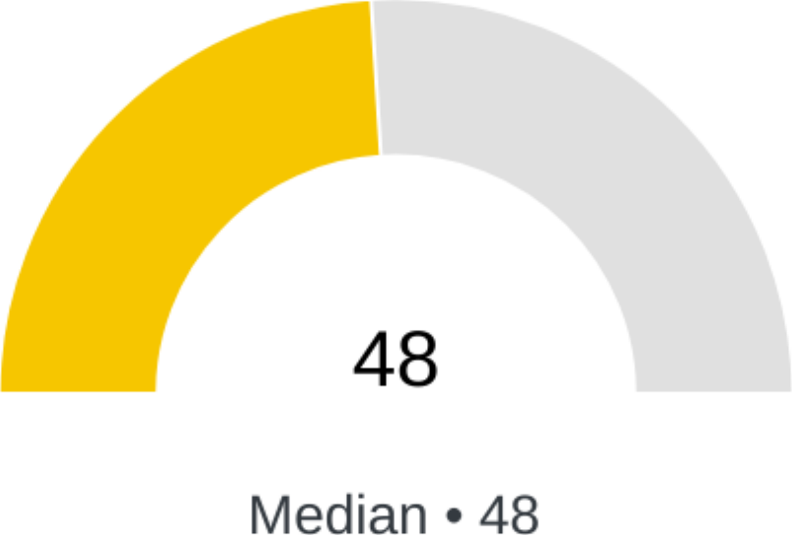
What types of human support do members have access to?
As much as we may like digital self-service tools, when healthcare is complex or expensive, it also gets scary. Human support from trusted resources is critical. The highest-performing plans ensure that members have a single point person to go to for support. Ideally, this person (e.g., member champion, nurse navigator, primary care doctor, etc.) has built trust with the member before a complex need arises.
YOUR RESPONSE: Care/clinical concierge/advocate/navigator; Designated member champion at plan sponsor (not just HR team)
POINTS SCORE: 6/12 possible points
KEY ISSUES
Having some form of human support for members goes a long way in making sure members are getting the care they need. Whichever form you choose, make sure it's consistent, easy to follow, and effective.
ADDITIONAL RECOMMENDATIONS
Congratulations on having a type of benefitsconcierge/advocate/navigator/champion to support members through a wide range of issues. Some are more focused on clinical issues while others are more focused on care and benefits logistics/education support. We recommend working with your advisor during your next renewal to ensure your solutions address all of these issues. Frequently, advanced primary care is part of the most effective strategies.

What types of digital tools do members have access to?
Many questions members have about their health plan can be readily addressed through electronic tools. The most compelling options combine all member information and activity into single web and mobile interfaces. However, it's important to not lose sight that making your plan easy for members to understand and ongoing education about the plan is far more important than how many features the plan's mobile app has.
YOUR RESPONSE: Member concierge/advocate/navigator app or web portal; Pharmacy-only mobile app; Pharmacy-only web portal
POINTS SCORE: 5/11 possible points
KEY ISSUES
Congratulations, your plan has a single place for members to go to interact with the plan. The features of apps and portals vary significantly, we recommend reviewing whether members are able to view information, make basic requests, or ideally, can directly chat with concierges/navigators/customer service.
ADDITIONAL RECOMMENDATIONS
Because BenAdmin portals are generally flexible, they can be a good place to communicate ad hoc benefits related communications. If you're not doing this yet, we recommend considering this as part of your strategy during your next renewal.

Value Based Primary Care

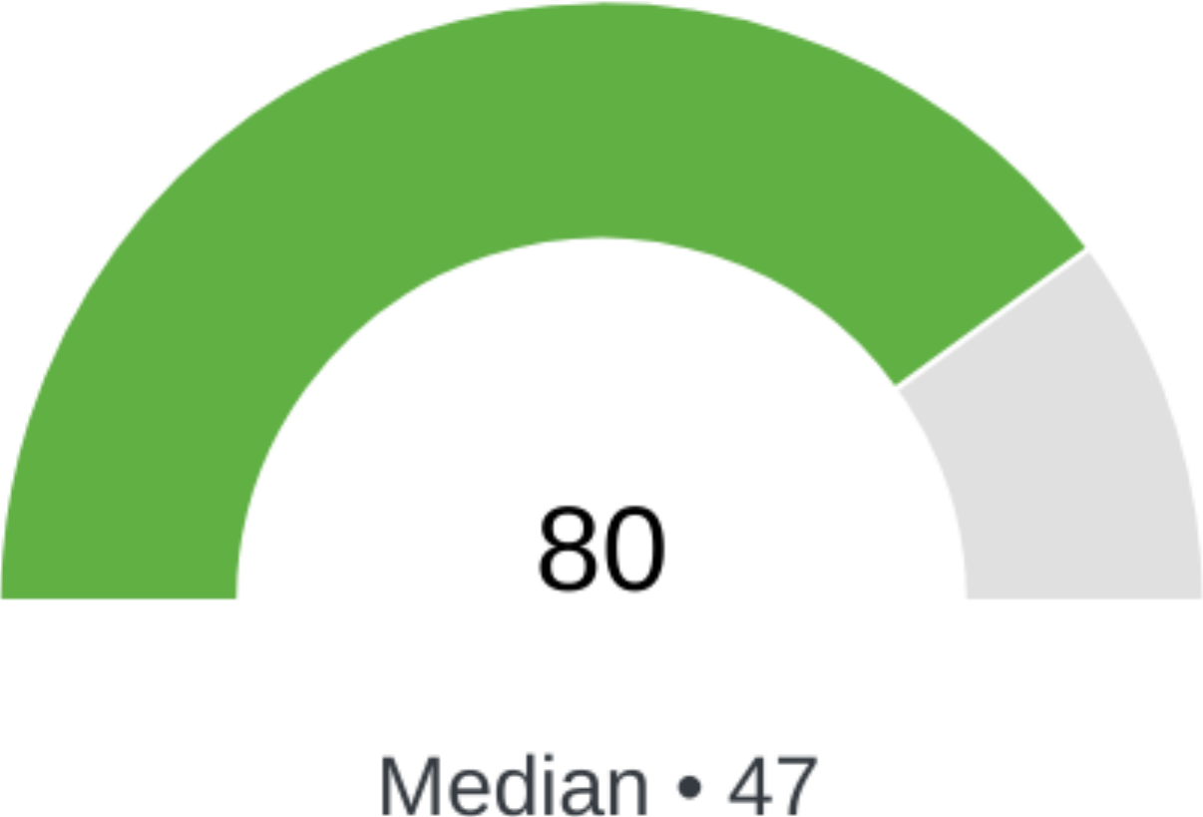
How are primary care physicians paid by the plan for standard primary care services?
One of the most foundational failings of our healthcare system is paying for primary care via fee-for-service. It creates misaligned incentives and poor care. Ever experienced the 7 minute appointment? Paying primary care more and in ways that incentivize effective care is one of the most valuable ways to improve care quality, member experience, and reduce overall plan cost.
YOUR RESPONSE: Fee-for-Service w/ additional incentives
POINTS SCORE: 2/5 possible points
KEY ISSUES
Run, don't walk, away from fee-for-service primary care. It limits the ability of primary care providers to effectively care for your population, creating fertile ground for issues like the opioid crisis. From direct primary care to onsite/nearsite clinics to virtual primary care, a range of options have emerged that are far superior to fee-for-service primary care.
ADDITIONAL RECOMMENDATIONS
Incentivizing primary care providers that are primarily paid via fee-for-service can be a partially effective strategy, but the most effective primary care providers we've observed are paid via subscription or capitation.

What Value Based Primary Care strategies does the plan employ?
There is no single "right" model for improving primary care. Consider your population's geographic distribution, tech savviness, and the number of workers in a given location to identify the best options for your organization. Be sure to have an advisor who is well-versed in the trade-offs of the various options.
YOUR RESPONSE: Direct Primary Care
POINTS SCORE: 6/6 possible points
KEY ISSUES
Congratulations, you're already adopting some form of value based primary care. We recommend reviewing your strategy with your advisor at your next renewal to determine whether you've fully adopted this Health Rosetta component.
ADDITIONAL RECOMMENDATIONS
Be sure you do your due diligence on virtual primary care organizations. Some simple telehealth companies have done little more than rebrand themselves as virtual primary care. In contrast, the best virtual primary care models have rethought care delivery and accompanying risk management from the ground up. The best produce outcomes that are comparable to other Advanced Primary Care providers.

Transparent Open Networks

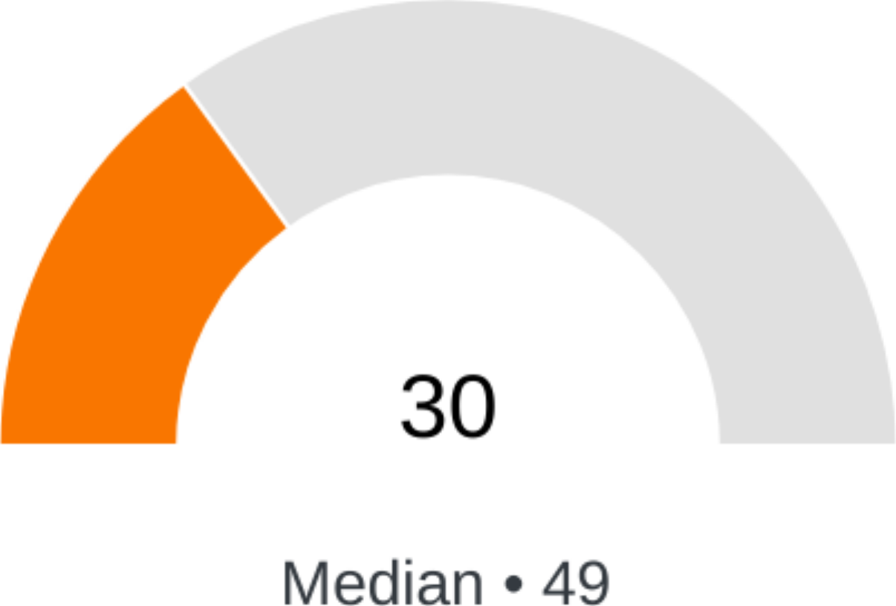
What network & physician access strategies does the current plan utilize?
PPO networks, while often still necessary to meet population needs, have proven to be ineffective at delivering value. There is a wide array of emerging options for working with care providers. We've observed that all high-performing plans are utilizing some of these alternative access and reimbursement strategies. The right benefits advisor is critical to helping you choose the right approaches for your plan.
YOUR RESPONSE: Bundled care arrangements; Traditional physician only network
POINTS SCORE: 3/10 possible points
KEY ISSUES
Congratulations, you've adopted at least some strategies to address the shortcomings of traditional PPOs/EPOs/HMOs and other traditional networks. Tackling how your members access the best care at the best price is a complex topic that will typically take multiple years to fully address. Since you're already on the path, we recommend educating yourself on the available strategies and which best fit your organization's constraints and objectives. The right advisor is invaluable for helping you navigate selecting the right strategies and partners.
The right strategy may not require you to leave a traditional network but should definitely address shortcomings. Tackling this issue is more likely to address the unit costs of care better than any other strategy.

Major Specialties and Outlier Patients

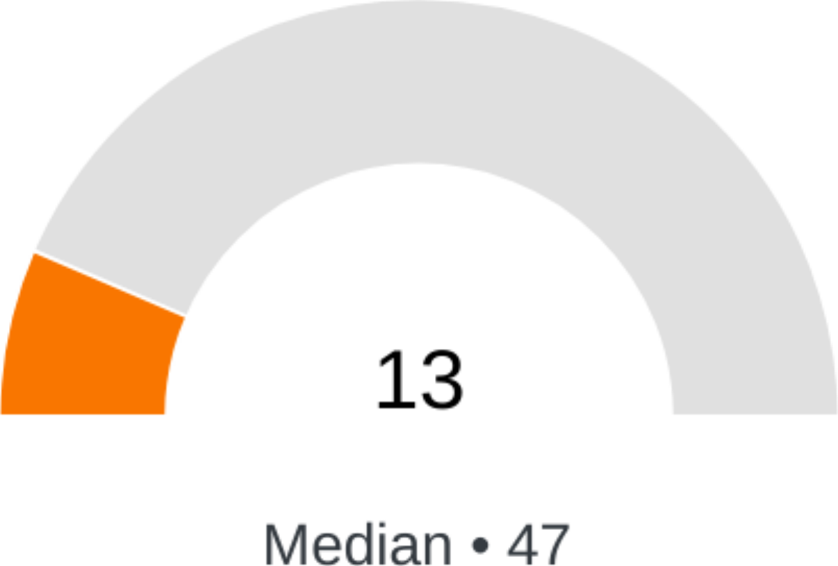
Which major specialty area(s) does the plan have specific strategies and programs for?
In a given year, as few as 6% of members can account for 80% of your total plan spend. This spend typically falls into major specialties where getting individuals to the best care possible is paramount. In some cases, the unit cost of care may even be more expensive. Tackling these major specialties is typically a combination of plan design, second opinions, access to center of excellence, focused vendor selection (sometimes), and effective care navigation.
YOUR RESPONSE: Dialysis; None; Other elective hospitalizations
POINTS SCORE: 3/24 possible points
KEY ISSUES
There are a wide range of specialty areas that require specific strategies to tackle. Because of the breadth of this, we recommend working with your advisor to create, review, and/or improve your strategy to address these specialties. We've found that frequently the most effective place to start is cancer, orthopedics, maternity, transplants, specialty drugs, and mental health because they can have the most immediate improvements in both cost and quality, as well as being high cost and utilization specialties in nearly every plan.
Remember, building a strategy for each specialty doesn't mean having a separate vendor for each specialty. Frequently, advanced primary care can tackle at least some elements of an effective strategy for every specialty, so that may be a great place to start.
ADDITIONAL RECOMMENDATIONS
Specialty drugs are quickly becoming one of the most expensive areas of care, so tackling this area is becoming more and more critical.
Research shows that more than 25% of all cancer cases are either misdiagnosed or have an inappropriate treatment plan, making it one of the most important specialties to address.
Orthopedic procedures are a great place to start because they can be planned for, orthopedics is usually a top 3 area of spend, and there are multiple mature options in the market.
Transplants are a must-tackle specialty because of the risk they post to your plan's viability. They aren't common, but they have enormous costs and there are many mature options in the market to tackle the cost and quality of them.

What other strategies does the plan leverage to help members access lower cost and higher quality care for complex care episodes?
Naturally, not everything listed here can be tackled at once. Typically, advanced primary care strategies paired with analytics to track key metrics can tackle most of these issues without adopting a bunch of different vendors for each area. For example, in most cases typical wellness programs have been found to have no financial ROI or improvement in care.
YOUR RESPONSE: Biometric Screening; Large Case Management
POINTS SCORE: 2/15 possible points
KEY ISSUES
Selecting the right mix of strategies to ensure your members get the best case for complex care episodes is an ever-evolving issue. The options in this question include many of the approaches we've observed plans leverage.
ADDITIONAL RECOMMENDATIONS
A concierge member service that can guide members dealing with complex procedures and conditions is the exact support they need when they're most vulnerable. We recommend tackling this issue with your advisor at your next renewal.

Transparent Pharmacy Benefits

What elements are included in the pharmacy benefit plan?
Pharmacy is complex, but the right PBM paired with effective contract negotiation will solve most critical issues. We've observed more than 30 different revenue streams PBMs have created for themselves. It's striking that all three big PBMs are Fortune 50 companies, yet not a single pure pharmaceutical company is in the Fortune 50.
YOUR RESPONSE: Contractual language that plan owns Rx data; Step therapy/starter dose programs to ensure appropriate opioid dispensing
POINTS SCORE: 2/9 possible points
KEY ISSUES
Looks like you've tackled at least some foundational issues for building a high-performance pharmacy plan. We recommend reviewing your strategy with your advisor and tackling any other low hanging fruit during your next renewal. Note that not all options here are appropriate for every plan.

Who reviews the plan's PBM contract?
A Health Rosetta ecosystem member shared a story from their time at a major PBM. In an internal meeting, they were discussing with their legal counsel negotiating strategy with a famous Fortune 50 company known for its expertise in procurement. The conclusion was that the company didn't stand a chance because the PBM had so many profit-generating items in the contract that the company didn't even know how to negotiate. Moral of the story? Getting a good PBM agreement requires a fundamental reset and negotiation by both lawyers and subject matter experts with a mission-aligned PBM that will agree to key contractual provisions.
YOUR RESPONSE: ERISA attorney at the advisor's firm; No third-party review
POINTS SCORE: 5/8 possible points
KEY ISSUES
Congratulations, you've had at least some level of review of your PBM agreement, which is more than most plans. Ideally, your own ERISA attorney and a pharmacy expert would review this, but frequently you can rely on an advisor or other solution that does the legal and pharmacy expert reviews on your behalf. We recommend confirming that your agreement is optimized during your next renewal.
ADDITIONAL RECOMMENDATIONS
If you've only had a legal review of your agreement, be sure to have a domain expert like a pharmacy consultant, an expert at your advisor's firm, or other third-party service review your agreement for complex business issues that attorneys aren't experts in.

What contractual guarantees does the plan's PBM contract have?
If there was ever a case of "the devil is in the details," it would be in PBM contracts. An effectively negotiated PBM contract directly creates ROI without requiring behavior change in a way that no other strategy can. You'll need both legal and pharmacy expertise to tackle this. Your advisor can help guide you.
YOUR RESPONSE: Guaranteed PEPM spend; Pass-through of all rebates without holdbacks or limitations
POINTS SCORE: 2/7 possible points
KEY ISSUES
Congratulations, looks like you've tackled at least some key contractual terms. We focus on specific terms in pharmacy contracts because there is a direct connection between your contract's terms and reducing your RX spend. If you haven't had a comprehensive review by both attorneys and pharmacy experts, we highly recommend addressing this during your next renewal. If you're fully-insured, this is one more reason to consider some type of self-funding that gives you the flexibility to address this.

What types of add-in pharmacy programs and strategies does the plan leverage?
Leaving no stone unturned is a good drug procurement rule of thumb. Targeted add-in pharmacy programs can provide strong financial returns without major changes to the plan. These are often where many plans start their journey. However, some strategies have complex nuances (such as compliance issues) to navigate, so selecting the right options requires working with the right advisors.
YOUR RESPONSE: International sourcing; Specialty drug carve outs
POINTS SCORE: 3/6 possible points
KEY ISSUES
Congratulations, looks like you've adopted at least some add-in strategies provided by your PBM or a third party vendor. However, we recommend reviewing claims data to ensure you're tackling as many issues as possible with your current strategy. Also, note that some of the strategies here have complex compliance issues that need to be effectively discussed and addressed with your advisor independently of what vendors try to sell you.

